**VISVESVARAYA TECHNOLOGICAL UNIVERSITY**

**JNANA SANGAMA, BELAGAVI – 590 018, KARNATAKA**

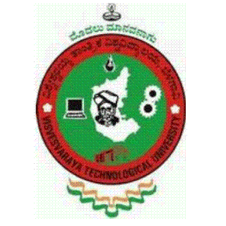

**A PROJECT SYNOPSIS ON**

**“HYBRID DOCUMENT SUMMERIZATION”**

**Submitted By**

|  |  |
| --- | --- |
| **NAVEEN P PANDURANGI**  **1VK15CS034** | **SRIVATSA JAMADAGNI**  **1VK15CS054** |
| **NIKHIL CHANDRAN**  **1K15CS038** | **MOHAMMAD ABU**  **1VK15CS030** |

**BACHELOR OF ENGINEERING**

**IN**

**COMPUTER SCIENCE AND ENGINEERING**

**UNDER THE GUIDANCE OF**

**Mrs. Chandramma R** B.E, M.Tech (Ph.D)

Assoc. Professor, Dept. of CS&E, VKIT, Bengaluru.



**Janatha Education Society®**

**DEPARTMENT OF COMPUTER SCIENCE AND ENGINEERING**

**VIVEKANANDA INSTITUTE OF TECHNOLOGY**

**GUDIMAVU, KUMBALAGODU POST, KENGERI HOBLI, BENGALURU –560 074**